**FUNCTIONS**

**Review Functions**

Give yourself a pat on the back, you just navigated through functions!

In this lesson, we covered some important concepts about functions:

* A *function* is a reusable block of code that groups together a sequence of statements to perform a specific task.
* A *function declaration* :

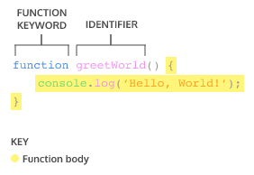

* A parameter is a named variable inside a function’s block which will be assigned the value of the argument passed in when the function is invoked:

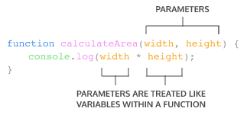

* To *call* a function in your code:

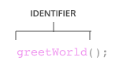

* ES6 introduces new ways of handling arbitrary parameters through *default parameters* which allow us to assign a default value to a parameter in case no argument is passed into the function.
* To return a value from a function, we use a *return statement*.
* To define a function using *function expressions*:

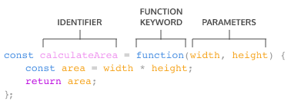

* To define a function using *arrow function notation*:

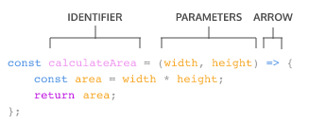

* Function definition can be made concise using concise arrow notation:

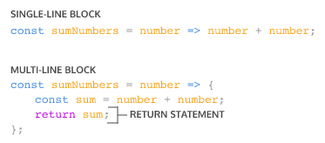

It’s good to be aware of the differences between function expressions, arrow functions, and function declarations. As you program more in JavaScript, you’ll see a wide variety of how these function types are used.